EXPERIMENT 3

1.

void setup()

{

pinMode(9, OUTPUT);

}

void loop()

{

for(int i=0; i<5; i++)

{

tone(9,440);

delay(500);

noTone(9);

delay(500);

}

}

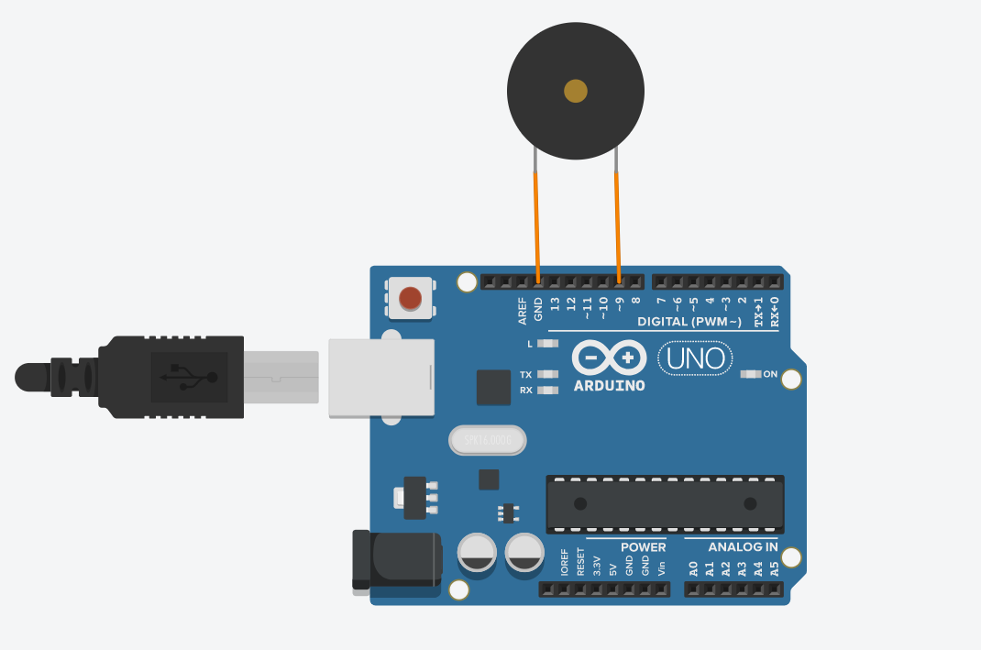

**2**

int led_State = LOW;

long previousMillis = 0;

void setup()

{

pinMode(9, OUTPUT);

}

void loop()

{

unsigned long currentMillis = millis();

if(currentMillis - previousMillis > 1000)

{

previousMillis = currentMillis;

if (led_State == LOW)

{

led_State = HIGH;

}

else

{

led_State = LOW;

}

digitalWrite(9, led_State);

}

}

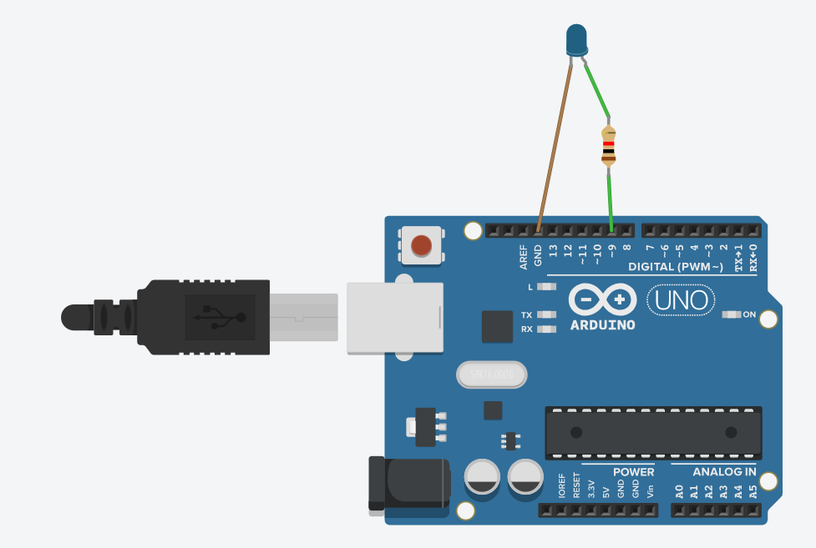

**3.**

void setup()

{

pinMode(2, INPUT_PULLUP);

pinMode(9, OUTPUT);

}

void loop()

{

int buttonState = digitalRead(2);

if (buttonState == 0)

{

digitalWrite(9, HIGH);

}

else

{

digitalWrite(9, LOW);

}

}

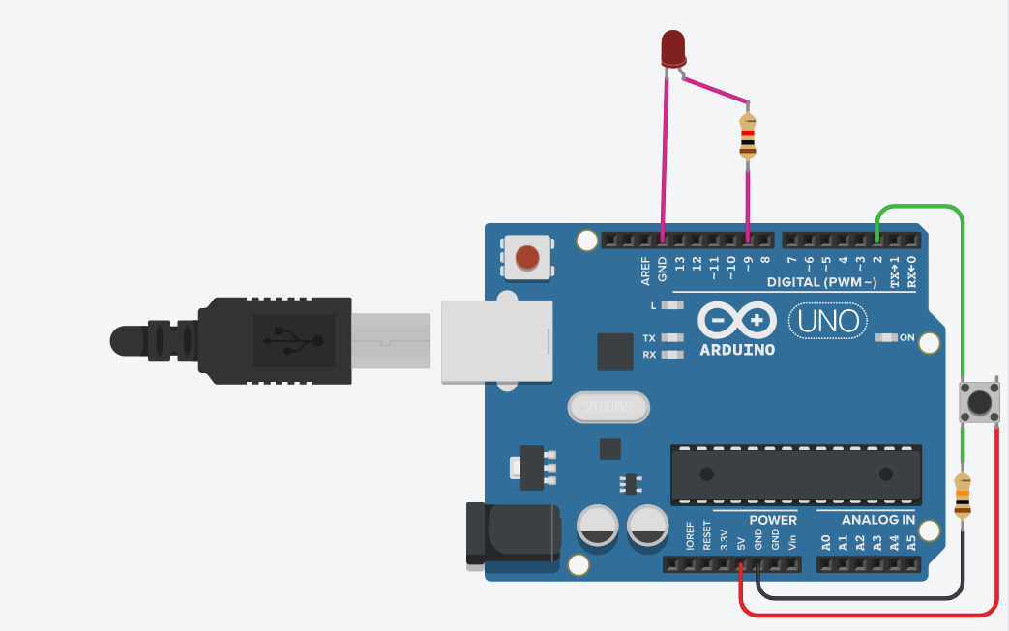

**4.**

void setup()

{

pinMode(13, OUTPUT);//Red

pinMode(12, OUTPUT);//Blue

pinMode(11, OUTPUT);//Green

}

void loop()

{

for (int i=0; i<5; i++)

{

digitalWrite(13, HIGH);

delay(500);

digitalWrite(13, LOW);

delay(500);

}

digitalWrite(12, HIGH);

delay(1000);

digitalWrite(12, LOW);

delay(500);

for (int i=0; i<5; i++)

{

digitalWrite(11, HIGH);

delay(500);

digitalWrite(11, LOW);

delay(500);

}

}

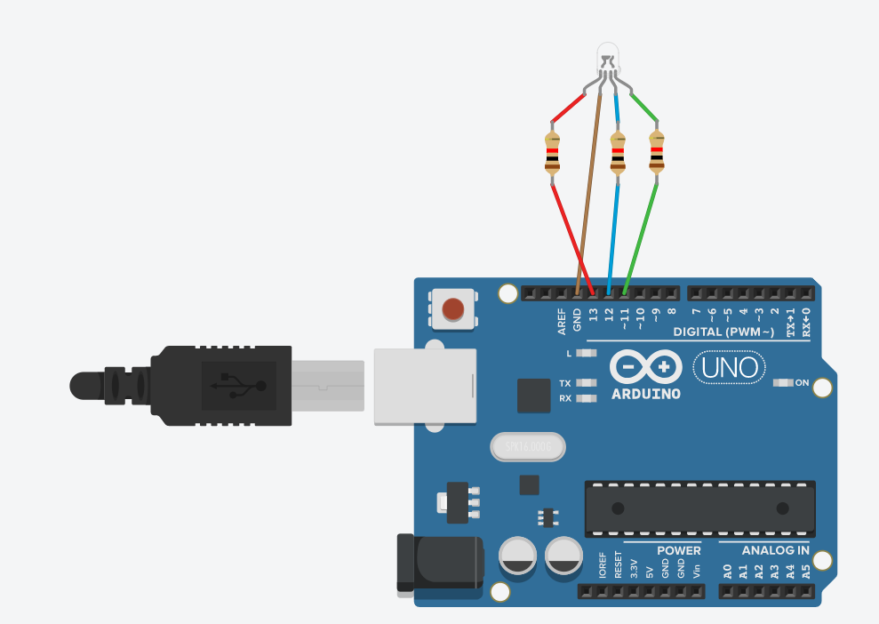

**5.**

void setup()

{

pinMode(A0, INPUT);

pinMode(9, OUTPUT);

}

void loop()

{

int sensorValue = analogRead(A0);

tone(9,sensorValue);

delay(500);

noTone(9);

}

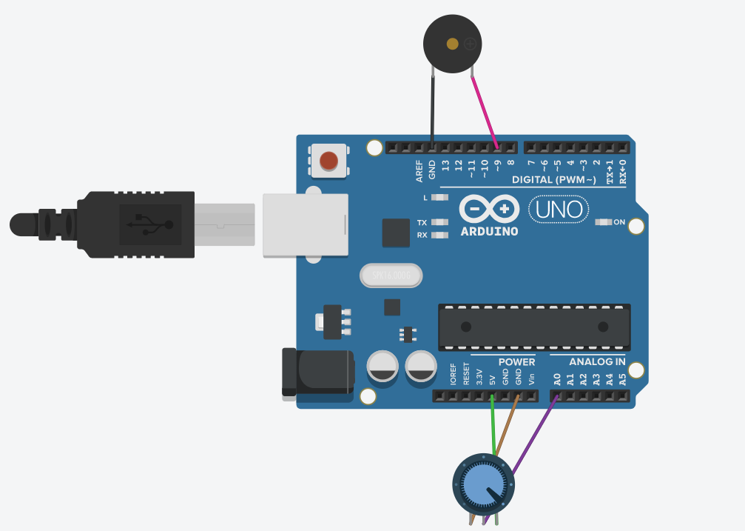

**6.**

int buttonState = 0;

void setup()

{

pinMode(2, INPUT);

pinMode(9, OUTPUT);

}

void loop()

{

buttonState = digitalRead(2);

if (buttonState == 1)

{

tone(9, 440);

}

else

{

noTone(9);

}

delay(10);

}

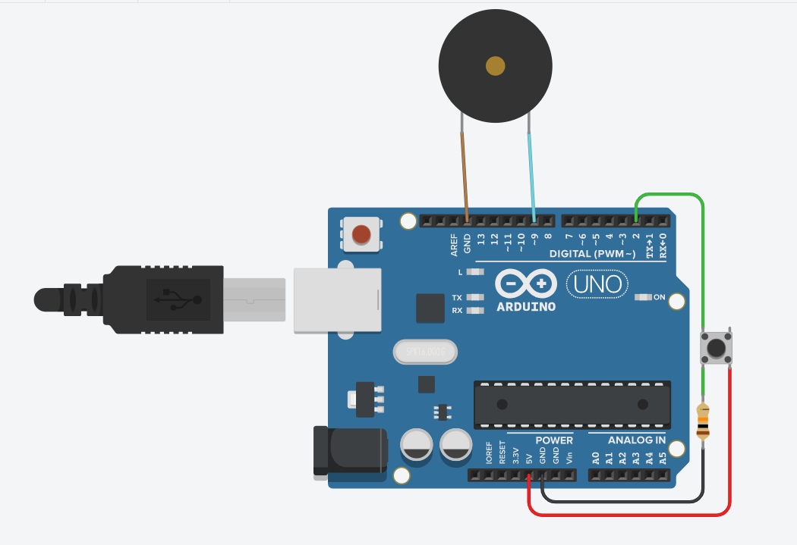

**7.**

void setup()

{

pinMode(12, OUTPUT);//buzzer

pinMode(11, OUTPUT);//red

pinMode(10, OUTPUT);//yellow

pinMode(9, OUTPUT);//green

}

void loop()

{

digitalWrite(11, HIGH);

delay(4000);

digitalWrite(11, LOW);

tone(12, 770);

delay(1500);

noTone(12);

for (int i=0; i<5; i++)

{

digitalWrite(10, HIGH);

delay(1000);

digitalWrite(10, LOW);

delay(1000);

}

digitalWrite(9, HIGH);

delay(4000);

digitalWrite(9, LOW);

tone(12,770);

delay(1500);

noTone(12);

}

